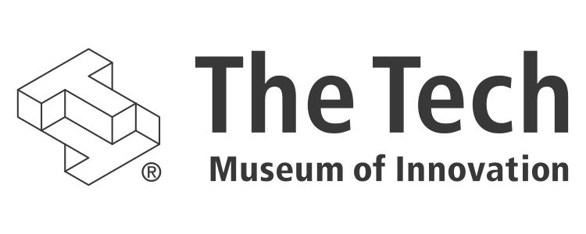

DIY Genetics: A New Exhibition  
Phase 1 opening fall 2015

# the tech. reinvented.

In 2012, The Tech Museum of Innovation launched a five-year institutional transformation to redefine the museum as a Silicon Valley resource for innovation. The Tech aims to do this by creating deep experiences that are open-ended, social, and collaborative. Newly opened lower-level galleries include Social Robots, which challenges visitors to design and program a robot for human interactions in real-world settings, and Body Metrics, which uses technology to create a digital reflection of visitors that enables them to assess their lifestyles’ influence on health in new ways.

In spring 2015 The Tech will open an only-in-Silicon-Valley cyber security exhibit in which visitors take on the role of a security professional facing cyber challenges to protect data and privacy.

And in winter 2015, The Tech will unveil DIY Genetics, the most provocative and hands-on museum bioengineering gallery ever.

# why do-it-yourself genetics?

“Bio-” will be the prefix of innovation for the near future. Bio-inspired, bio-derived, and bio-designed technologies already are becoming commonplace in current research and startup industries. Biology-based innovation bridges sci-fi with reality as it taps life’s basic functions, identifies commonalities across the incredible diversity of life, and provides new hypotheses for repurposing the power of the biological world.

The DIY Genetics exhibition will be a place where people of all ages can create with biology. To advance The Tech’s mission to inspire the innovator in everyone, the exhibit will deliver much more than knowledge. It will demystify synthetic biology, helping visitors build confidence in this dynamic field and gain new perspective to fuel creative problem-solving.

Synthetic biology breaks life down into fundamental parts that can be snapped together like Tinkertoys to create new, useful systems and outputs. Advances in synthetic biology are already being applied to address some of today’s most pressing issues, from agriculture to medicine to fuel. By harnessing the power of biological systems, scientists are finding new ways to feed the world and clean up the environment. One day computers may have bio-derived parts and biosensors may be the norm in cancer treatment.

The DIY Genetics exhibition will encourage visitors to play, tinker, and design with biology. Imagine entering a gallery space transformed into a community laboratory that is both inspiring and approachable – a biotinkering playground that sparks imagination and confidence with this cutting-edge technology.

The Tech believes in helping build a generation that is interested in and able to apply a biological mindset and toolkit. This exhibit will cultivate an excitement for synthetic biology that traditional educational settings are failing to do. Today’s students need a new model of informal education where hard sciences are made tinkerable, especially in subjects like bioengineering, for which textbooks and curricula cannot keep up with the technological advancements. Open-ended exploration of unfamiliar objects and concepts are often cited as the inspiration for new technologies and companies. This exhibit will foster more of the early-age instances of awe and excitement that lead to a passion for science and discovery that lasts a lifetime.

# what is the diy genetics exhibition?

DIY Genetics will replace the current Genetics with a Twist gallery in The Tech. It will feature four content clusters: **Bio-Basics, Wet Lab, Tinkering with Biology** (which includes the Biodesign Toolbox and Biotinkering Workshop) and **Synthetica**. A sketch of the gallery:

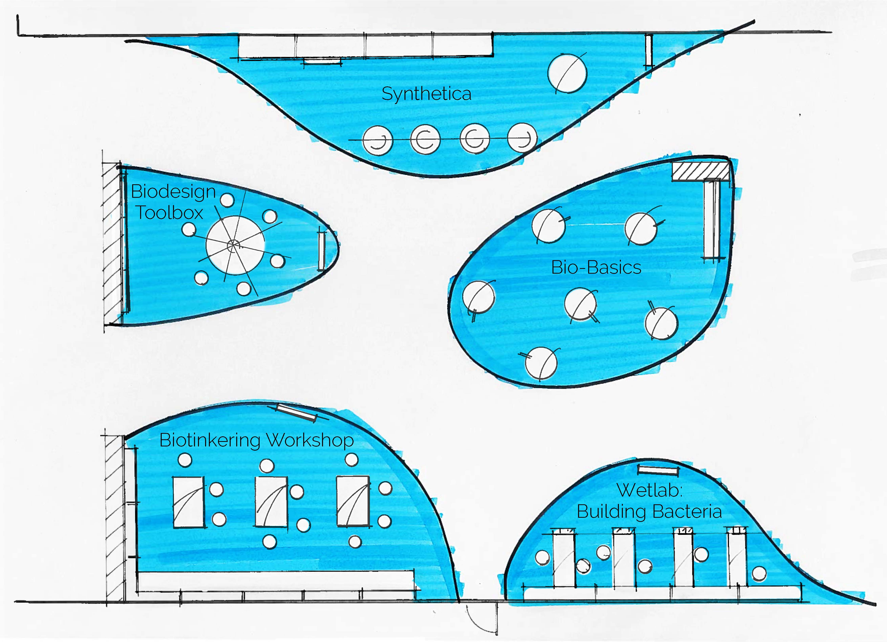

#### 1. Bio-Basics (biology-specific interactives)

This area will be filled with stand-alone interactive exhibits that encourage visitors to explore what makes biology unique. Such important concepts include the genetic code, functional forms, exponential growth, and biological self-assembly. (Self-assembly allows complex biological structures and systems to organize into coherent, fully functional forms without external direction.)

**A sample walkthrough:**

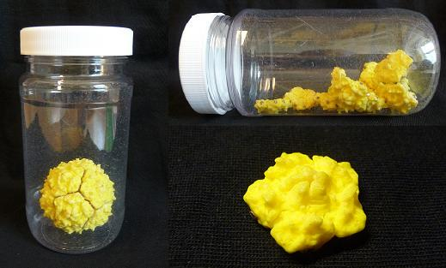*Maria approaches the self-assembly area — a round, cell-themed vibrating table where 3D-printed proteins are haphazardly moving about, most of time briefly sticking together (through integrated magnets) and sometimes building larger structures that remain together much longer. She picks up a clear container filled with identical pieces and labeled “shake me.” After trying a few different rhythms, she sees the pieces begin to form a hollow sphere by themselves.*

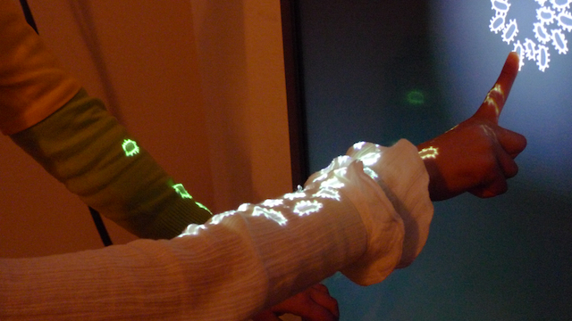*At another table in the area, Maria sees a video projection from above. The projection is of hundreds of wiggling bacterial forms that pop out of existence when she taps on them. She can even wipe the table to clear many at a time, but they immediately divide and fill the empty space again. She lingers a little at the table and notices that the bacteria are starting to be projected onto and multiplying on her clothing as well!*

**2. Wet Lab: Building Bacteria with Biobricks**

After 10 years, the current wet lab will get a much-needed expansion and update. The new wet lab experiment will invite visitors to create new “living colors.” Visitors will don their gloves and goggles and create new bacteria hues. Engineering living color improves upon the current bacteria transformation experiment with jellyfish DNA by taking the experience a step further. The current experiment had only one possible outcome. The new wet lab experiment is more open-ended with unpredictable outcomes, and the added steps of interactive color discovery and measurement deepen the experience. These new steps provide context and meaning to the activity as well as reinforce basic bioengineering methods and applications.

**A sample walkthrough:**

*A member of The Tech’s gallery staff guides Sean to a wet lab station with all the basic tools to perform genetic engineering. Small pipettes, plastic vials filled with DNA and bacteria, petri dishes, and special vial holders to keep things cold or hot are arranged next to a screen. The interactive screen guides Sean through the hands-on bacterial transformation activity at his own pace. Through the process he learns that he is performing his first synthetic biology experiment: This wet lab is part of 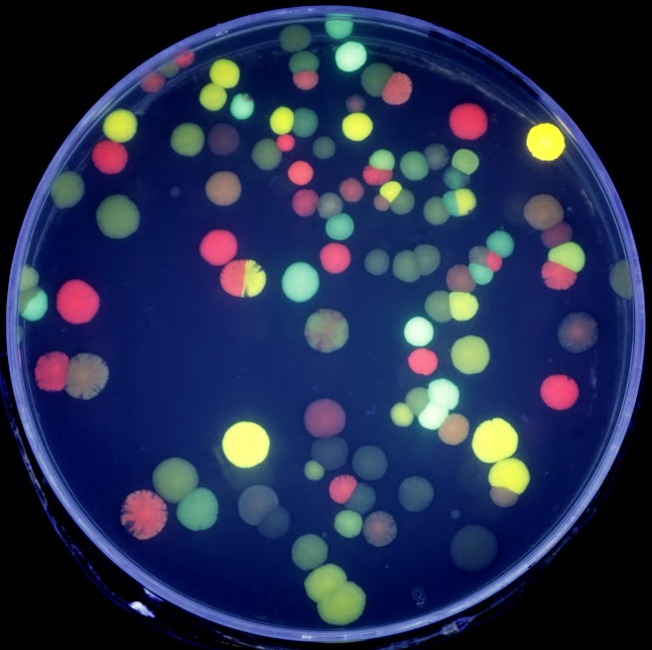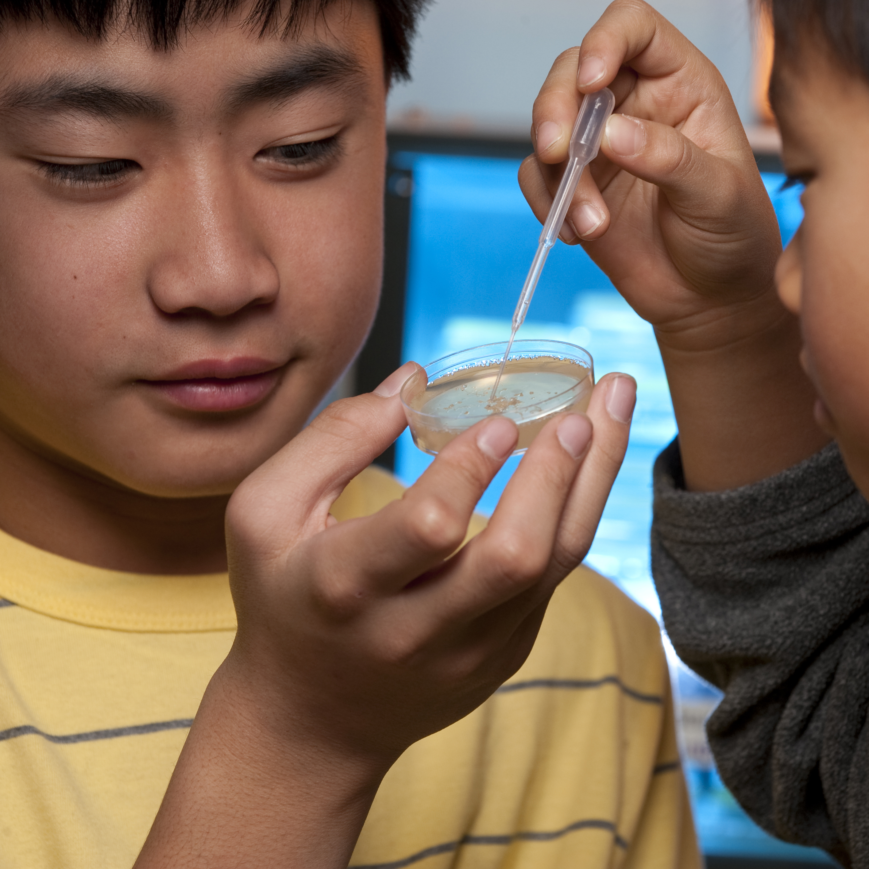a collective community science experiment that The Tech is running to find as many bacterial colors as possible using synthetic DNA that turns each bacteria into a “living pixel” with different red, blue, and yellow proteins. The end product is a growing plate of unique bacteria that Sean places in the incubator for viewing the next day online at my.thetech.org (thanks to The Tech’s unique Smart Museum capabilities).*

*Adjacent to the genetic engineering area is a station with a stack of plates that other visitors made the previous day, showing a wide variety of colors that can be seen with the naked eye. This is the “visualization station,” where Sean can hunt for rare colors created by bacteria.*

**3. Tinkering with Biology**

Making biology truly tinkerable requires a kit of parts and open-ended play space where visitors can experiment with materials and ideas to fully understand their capacities. As visitors iterate and learn from failure, they can find better solutions to current problems. But equally important, visitors should be allowed unstructured time to explore and invent. To achieve these ambitious goals, we will pair a virtual design experience, the Biodesign Toolbox, with a hands-on activity. That means the virtual biological construct created at the Biodesign Toolbox will be brought to life in the hands-on Biotinkering Workshop.

Biodesign Toolbox (digital DNA design activity)

This exhibit is a thematic counterpart to the Wet Lab. It is a virtual space where “biobricks” (modular DNA components) can be assembled and arranged. This will be the core design challenge of the exhibition, where visitors explore how biological parts interact and can be put together to build complex systems. Emphasis will be placed on genuine biodesign principles and applying synthetic biology to solve real-world problems – participants will address the same questions university and industry bioengineers are tackling. Visitors will mix and match virtual pieces of DNA and genes to solve a selected problem. A visitor can also opt for open-ended tinkering.

Biotinkering Workshop (test kitchen)

The culminating experience of the biodesign activity area will take place in this well-stocked biotinkering test kitchen. Various pieces of DNA, bacteria, and other biological parts will be made available to visitors through a DNA Vending Machine. In the workshop, visitors can actively experiment with the designs they developed in the Biodesign Toolbox – here, their virtual creations become real. On the shelves of the workshop will be the reagents (substances and chemical mixtures) and environmental conditions necessary for visitors to test whether their designs function as expected.

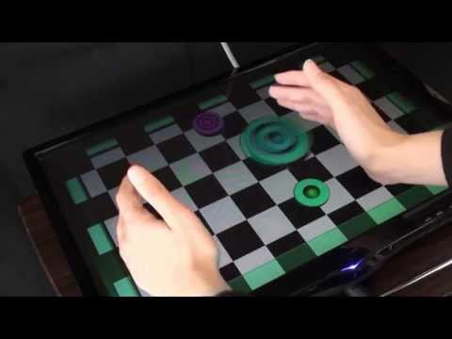**A sample walkthrough:**

*Sophia approaches a large hexagonal touchscreen table. In the center of the table she sees a communal virtual Biodesign Toolbox filled with a diverse array of alluring DNA pieces (biobricks) with different functions and uses. At her workspace, she receives a prompt to take on a real-world bioengineering challenge or explore in open-ended play.*

*Today, Sophia decides to take on a specific problem and chooses “detect pollutants.” She is told about a company suspected of releasing pollutants into a river, but it is difficult to prove whether this is true. Her job is to engineer a strain of bacteria to do just that. First, she picks a piece of DNA to act as a sensor for the pollutant and another to give a detectable readout, such as a color. She swipes through the Biodesign Toolbox to find the parts she wants to try and drags them onto her personal workstation screen, where she experiments with putting them together in different ways. Her first strategy doesn’t work, so she goes back to the toolbox and chooses some more biobricks to test. Now, success! She saves and names her design to her account in the Smart Museum system.*

*Next, Sophia has the option of doing an actual experiment with her finished product in the Biotinkering Workshop. She uses her Tech Tag to record the information about her design and heads to the DNA Vending Machine. When she scans her Tech Tag, two tubes are dispensed from the machine. One tube contains bacteria with the DNA she designed already inside, and the other tube contains the “pollutant.” She takes two plates but only adds the pollutant to one of them. Then she spreads the engineered bacteria on both plates and will check online next day to see if her design really can detect the pollutant.*

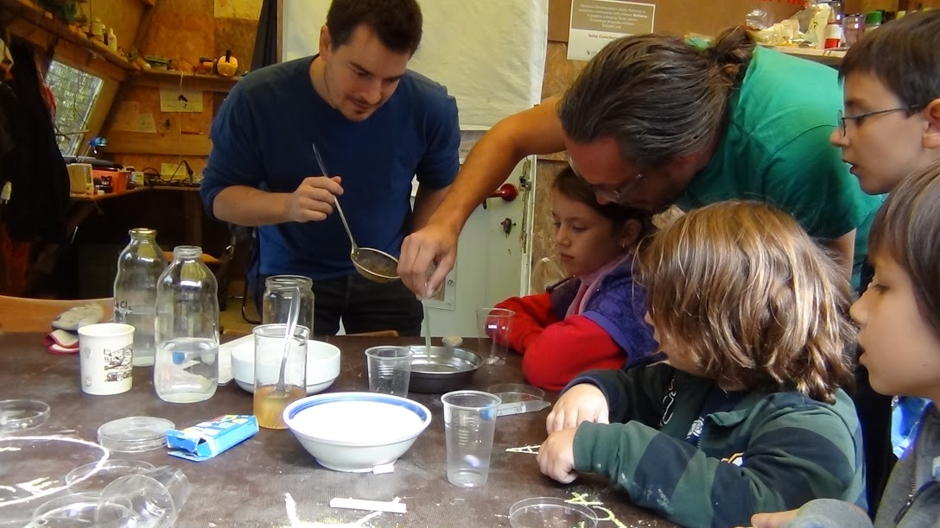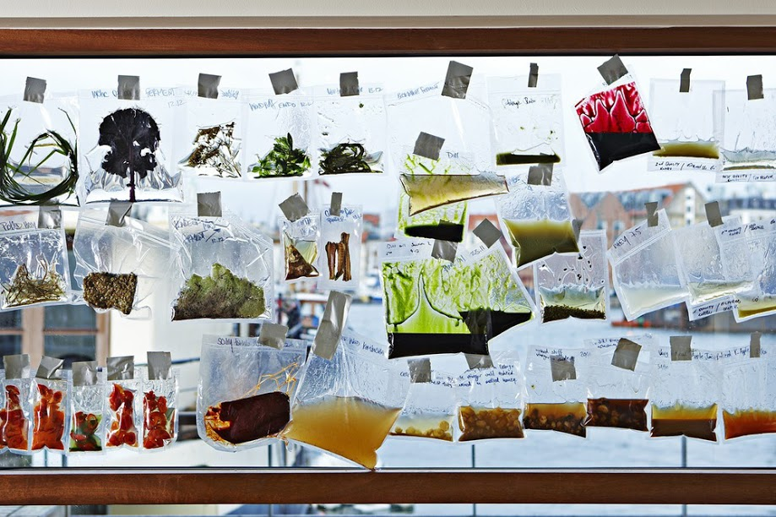*At a neighboring workstation, another visitor chooses to the open-ended option and explores what can be created with the biological parts and tools available. He grabs many different parts from the Biodesign Toolbox and plays with how these pieces fit together and interact.*

**4. Synthetica (Synthetic life forms)**

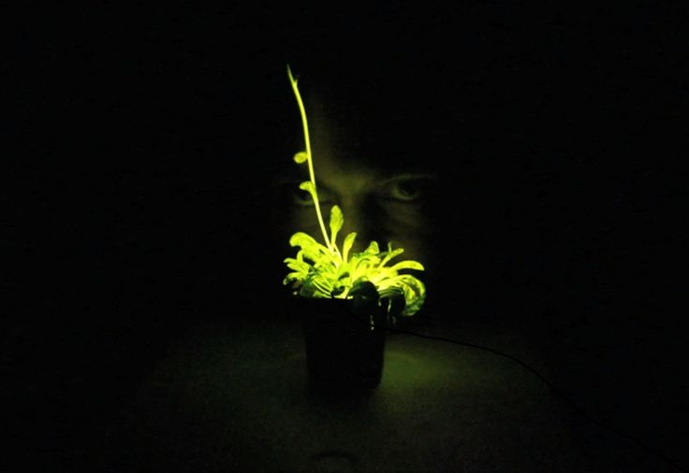To showcase tangible examples of genetic engineering, this living exhibit will highlight agricultural, artistic, and experimental samples of synthetic life forms. For example, during virtual experiments at the Biodesign Toolbox, visitors might be directed to Synthetica so they can visualize their idea as a living plant, animal, or microbe.

Preliminary designs for this area include displaying engineered agricultural products such as Golden Rice, which was created to combat blindness in children caused by Vitamin A deficiency, and various food crops engineered for high yield and pest resistance.

Other provocative organisms being considered are: Glofish, a fluorescent ornamental fish; flowers that change colors throughout the day; and microorganisms (e.g. bacteria) that have been designed to be aromatic, to be uniquely textured for raw materials, or to possess other useful properties. These synthetic life forms can help visitors elevate their thinking about what is possible in the bold new realm of synthetic biology. We hope to break conventional mindsets and dare visitors to imagine something that has yet to be discovered.

Synthetica will be a visual feast that will draw visitors to the DIY Genetics gallery and provide a backdrop for discussions and reflection about practical as well as ethical questions surrounding genetic engineering. There will be a platform to pose questions directly to Stanford Genetics Department experts, which will be answered on The Tech’s Ask a Geneticist website.

**NOTE:** DIY Genetics will be created next door to the new Innovations in Healthcare exhibition. The proximity of these exhibits is deliberate because DIY Genetics nurtures the bio innovator’s mindset and lets visitors experience invention. Then a few steps away, visitors will get to see the revolutionary work that results when creativity and risk-taking is unleashed. DIY Genetics will serve as a conceptual bridge to neighboring Innovations in Healthcare.

# the timeline

**Phase 1 (January 2014 to June 2015)**

Master planning for entire DIY Genetics space. This includes defining content, overall and localized design, mockups, prototyping, and research. Concurrently, we will refresh content for the wet lab, using this experience to prototype design and equipment. We have developed many prototypes and will continue to develop additional prototypes using the mobile lab.

**Phase 2 (June 2015 to December 2015)**

Complete production of exhibition gallery including content for Bio-Basics, Wet Lab, the Biodesign Toolbox and Synthetica. DIY Genetics will open to the public in winter 2015, as research and prototyping continues for Biotinkering Workshop content.

**Phase 3 (January 2016 to June 2016**)

Evaluation of beta-launched exhibits and interactives with revisions as necessary. Final development and installation of tools and content for the hands-on Biotinkering Workshop. Additional content for Biodesign Toolbox possible, if needed to complement Biotinkering Workshop.

**June 2016 to December 2024**

Every two years, the exhibition will be updated to keep content fresh and relevant. Exhibit engagement will be tracked and evaluated via the Smart Museum, and exhibit changes will react to these findings.

# smart museum integration

Smart Museum, made possible by the Gordon and Betty Moore Foundation, is the engine behind DIY Genetics. This exhibition more than any other will maximize the awesome capabilities of the Smart Museum to extend learning at the museum and beyond. Each creation and experience in DIY Genetics will be stored in the visitor’s Smart Museum account so that information can be retrieved as the visitor migrates between stations and between visits. For the Wet Lab experience, next-day outcomes could not be tracked without Smart Museum. For the virtual Biodesign Toolbox, activity results must be stored in Smart Museum for the visitor to continue that experience in the Biotinkering Workshop. In addition, Smart Museum provides an opportunity for each biological concept introduced in this gallery to be further explored online, when a visitor logs on to my.thetech.org to see his/her creations. Data collected through Smart Museum also will provide detailed insight into visitor engagement and help shape how the exhibition should focus its regular enhancements over the next decade.

# additional programming

This exhibition will propel additional museum programming on genetics and bioengineering at The Tech that includes guest lectures, hackathons, meet-ups, and other community events that foster innovation. The Biotinkering Workshop will be a new creative space – a biology-based Tech Studio – for everyone, particularly the Greater Bay Area’s robust bio community. The Tech will galvanize and localize discussions that would not happen without our dedication to serving as a community resource for innovation.

# the budget

**2014 expenditures: research and prototyping**

1. Personnel   
   Exhibit developer: $40,000

Prototyper: $25,000

Benefits and taxes: $16,250  
**Total personnel: $81,250**

1. Materials, supplies, equipment   
   Wet lab supplies: $1,000  
   Wet lab equipment: $2,000

Mobile wet lab: $10,000

iGem supplies: $3,500

Living GMOs (water/power/structure): $50,000

Living GMOs (permits): $20,000

**Total materials, supplies, equipment: $86,500**

1. Contractors/consultants   
   Living GMO consultants: $30,000  
   Software contractors: $18,000

Content adviser: $25,000

Stanford @ The Tech staff: $30,000  
**Total contractors/consultants: $103,000**

1. Conferences/travel   
   ASTC: $2,500  
   iGEM Jamboree: $5,000

**Total conferences/travel: $7,500**

**Total 2014: $278,250**

**2015 expenditures: gallery construction**

1. Construction  
   Fabrication, equipment, and production (25%): $300,000

Research, content development, and design (20%): $240,000

Piloting and mock-up (15%): $180,000

Engineering (10%): $120,000

Demo and installation (10%): $120,000

Contingency (10%): $120,000  
Evaluation and remediation (5%): $60,000

Misc. (5%): $60,000

**Total 2015: $1.2 million**

**2016 expenditures: Biotinkering workshop development**

1. Personnel   
   Exhibit developer: $40,000

Prototyper: $26,000

Benefits and taxes: $16,500  
**Total personnel: $82,500**

1. Materials, supplies, equipment (estimated): $143,750
2. Consultant/contractor (content adviser): $25,500

**Total 2016 (Biotinkering workshop): $251,750**

**2016-2024 expenditures**

1. Ongoing needs for exhibit  
   Gallery staff (2, avg. $65,000/year): $585,000

Exhibit updating (est. $150,000 every 2 years): $600,000

Materials, supplies, equipment (est. $65,000/year): $585,000  
**Total ongoing needs: $1.77 million**

**Total 2016-2024: $1.77 million**

**TOTAL EXPENSES $3.5 million.** $1 million already secured from the Brin Wojcicki Foundation.

# in gratitude

We value your consideration of partnership to support this work at The Tech and in the Silicon Valley community and look forward to many years of mutually beneficial collaboration. If you have any questions, we would be happy to discuss them and share more details of this exciting project. Thank you for your consideration of this philanthropic opportunity.

For information, contact:   
**Maria Pappas**Vice President, Development  
(408) 795-6301  
mpappas@thetech.org  
